**You Tour**

**SRS**

**Introduced by SE2018G08**

1. **Introduction:**
   1. **Executive Summary**

YouTour is a website which works like a platform for a number of tourism companies to offer their trips which are varying in cost & duration so that the customers will always find an offer satisfies their needs, the website also provides different ways of filtration to make it more easier for customers to get their point and many other user friendly functions.

* 1. **Document Overview**

Thissrsdocument focuses on describing the software requirements of YouTour website, The document focuses on system description, system users,system modules, all the functional, non-functionalrequirements and system interfaces.

* 1. **Abbreviations and Terminologies**

|  |  |
| --- | --- |
| SRS | Software requirement specifications |
| GUI | Graphical user interface |
|  |  |
|  |  |

1. **system description:**
   1. **introduction :**

**2.1.1.about:**

You tour is a system that provides various offers for different travel agencies and tourism companies. The main idea behind the system is instead of browsing the packages and offers of just one travelling agency, the user will have the opportunity to go through a larger number of offers without the effort of going into each company's website. It offers a large number of trips that varies in destinations, hotels with different rates and the duration time, so users can decide where to spend their holidays. The site will provide different ways of filtration to make it easier for users to find what they are looking for .You tour also makes communication with different agencies become easier by providing their contacts (number, address, websites, and email).

**2.1.2.Product functionalities:**

**-**Search and filter:

The user can search and filter through all the offers to narrow down the options. The user can filter by three criteria. First is filtering by the place they want to go to then the system will get all the offers for that chosen place. The second one is by the cost of the package as a whole. The user can enter a range of cost that suits them and the system will provide them with offers within that range. The last one is filtering by the date/timing of the trips. The user can search using one or all the filters to facilitate the searching process.

- Provide detailed description of the offers:

The system provides a very detailed description for every offer so that the user can know all the information from our system and won't feel obliged to contact the companies for more information. The description includes the place they are going to visit, the program of the trip, its duration, the hotel and its rating, the available activities at that place, the transportation details (if the transportation is provided), the cost of the trip. It will also include any further details that the travel agencies provide regarding any trip.

-Having a user profile:

Users are either companies or customers. companies contribute to the system by providing their tours schedule (plan and description ) and their contacts .Customers browse the companies offers and book them using his account (only registered user can use initial booking,tracking atrip and rating options).

-Booking:

The system provides with each offer/trip the contact information (mobile number, email, website and location) for the travel agency so that when the user decides on a specific offer, they can contact the agency and book the offer they want. The system provides also initial booking, but if the customer doesn’t confirm it, it will be cancelled.

-Show the best offers:

The system provides the option to look at the best offers first before searching so that it's easier for the user to find what suits them best before exploring all the other options.

-Rating:

Users can rate their experiences with the system and the tour offers.

-Tracking the trip:

The detailed schedule of the trip will be sent to registered users who booked the trip, and once the trip starts the user will receive notifications on their account following the schedule notifying them of the place they should be in at the moment.

-Administration:

-Add a new user by enteringinformation of the new customer or company and delete any user.

-Check the company’s identity before letting them make an account.

-manage customers and companies profiles.

- manage all information and has access rights to view the data related to any company (places, travels, routes, bookings, restaurants etc) or any user and delete any of them if necessary.

-responsible for improving the website performance and security

**2.1.3.system development :**

2.1.3.1. Architecture:

This website application will be built using Html,css,bootstrap and java script for front end development (anything the user can watch or deal with )and the frame work django for the back end development(any action wil be taken by the user like login ,search, etc…).

* 1. **users:**

## Admin:someone who controls and manage all the system

## User:someone who can operate the website

## Customer: a registered user as a customer

## Company: a registered user as a company

## System users:

|  |  |
| --- | --- |
| Admin | -add new user-edit or delete any user info-add/edit/delete any trip |
| User | He/she can browse the website,view the different offers and feedbacks and get any company contacts. |
| Customer | He/she can make an account which allows him/her to reserve a trip or more,organize his/her trips plan and time table and rate the web site,the trip and the tourism company. |
| Company | Each company can make an account which allowing it- add its contacts.-add its trips description, cost, add time table.-get a list of the customers who reserve a trip. |

**4.System functions**

4.1.

|  |  |
| --- | --- |
| Register | Name |
| User (company/customer) | Actors |
| Open web site "You tour "  If person does not have an account he will sign up in first page in web site. | Precondition |
| |  |  | | --- | --- | | System response | Actors | | -The system is successful  The system is failure- | -You can log in as a user in a web site  And you will enter to your home page as a user you select "customer, company".  -User is unable to sign up for one or more reason like data is not correct. | | Post condition |
| |  |  | | --- | --- | | System response | Actors | | -The system prompts user for registration new account  -System creates account | -User select option to register  -User enter data to sign up(first name , , password ,email)  -Submit register button | | Steps |
| If you have an account you can log in. | Alternative |
| The user have to fill the required data (first-name, last-name,email, password and other data ). | Description |

|  |  |
| --- | --- |
| Log in | Name |
| User (admin ,company,customer) | Actors |
| If user has an account by signing up, he will log in with his (Email, password). | Precondition |
| |  |  | | --- | --- | | System response | Actors | | -The system is successful  -The system is failure | -User will enter to your home page.  -You can do available works in your page.  -If user not authenticated | | Post condition |
| |  |  | | --- | --- | | System response | Actors | | -The system validates the entered email and password ,making sure his data is valid  -The system direct to home page | -User enter email and password  -Click on login button | | Steps |
| |  |  | | --- | --- | | System response | Actors | | -The system describe why user failed authentication  -The system prompts the user to reenter valid data | -If you forget your password you will enter "forget password button" | | Alternative |
| If the customer need to view his trips or the company need to add ,edit ,..etc they have to login  to enter to your account.  If email or password is not correct, a warning message will be shown “Email or Password is not correct”. | Description |

4.2

4.3

|  |  |
| --- | --- |
| Log out | name |
| User (admin,company,customer) | Actors |
| None | Precondition |
| You will back to first page in web site and if you want to enter to your page again log in . | Post condition |
| |  |  | | --- | --- | | System response | Actors | | the system send massage if user want to save changes | User click on log out button | | steps |
| None | Alternative |
| When clicking on log out, it will log out the user from the site.  If you want to finish your works on web site click on log out. | Description |

4.4

|  |  |
| --- | --- |
| Name | Tracking the trip |
| description | In order to keep the website in touch with customer  The customer profile will allow the customer know where the rest of the group and it will send notifications to alarm the customers when an event is about to end . |

4.5

|  |  |
| --- | --- |
| Name | search |
| Description | The website allows the user to search by the trip name or destination. |
| Inputs | text of the name or the destination |
| Outputs | The trips which match the input. |
| Pre-conditions | The user isn’t allowed to enter numbersor symbols. |

4.6

|  |  |
| --- | --- |
| name | Cost filter |
| Description | the website allows the user to enter the max cost he/she can afford and it will view all the trips which cost are lower than or equal the input |
| inputs | numbers |
| outputs | trips which match the input cost . |
| Pre-conditions | the user isn’t allowed to enter any text or symbols. |

4.7

|  |  |
| --- | --- |
| Name | Destination filter |
| Description | the website allows the user to search by the trip destination. |
| inputs | text |
| outputs | the trips which match the input . |
| Pre-conditions | theuser isn’t allowed to enter numbers or symbols. |

4.8

|  |  |
| --- | --- |
| Name | Destination filter |
| Description | the website allows the user to search by the trip destination. |
| inputs | text |
| outputs | the trips which match the input . |
| Pre-conditions | theuser isn’t allowed to enternumbersor symbols. |

4.9

|  |  |
| --- | --- |
| Name | Date filter |
| Description | . the website allows the user to enter the date in this format dd/mm/yy to dd/mm/yy |
| inputs | numbers |
| outputs | the trips which date is between the selected interval |
| Pre-conditions | theuser isn’t allowed to enter text or symbols. |

5.system models

5.1. user and administrator use case

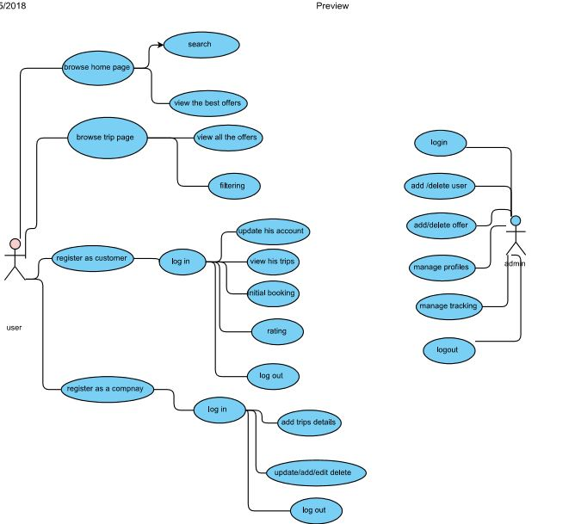

**6. Nonfunctional Requirements**

6.1. Performance:

-The system shall respond to the member in a short time.

-The system shall be allowed to take more time when doing large processing jobs.

6.2. Security:

-The system will be reliable.

-System will have different type of users and every user has access constraints.

-After entering the password the user can access his profile.

-The details of the user will be safe and secure.

6.3. Availability:

-The system is available for the user at any time.

6.4. Accuracy:

-The requirement and the system will be clear enough and more accurate with every process will be done on the system.

-If unable to process the request then appropriate error message.

6.5. Usability:

-The system is user friendly and online help makes using the system easy Reliability.

-The system will be protected well from failure and there will be a strategy for error detection and correction.